Install azure-cli in WSL



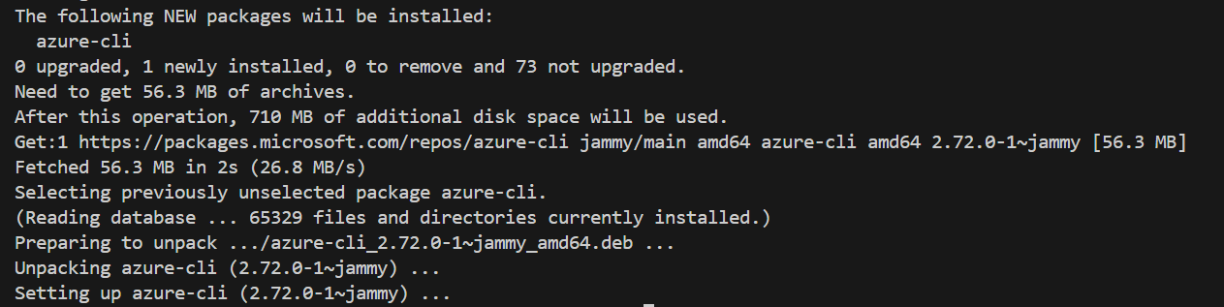

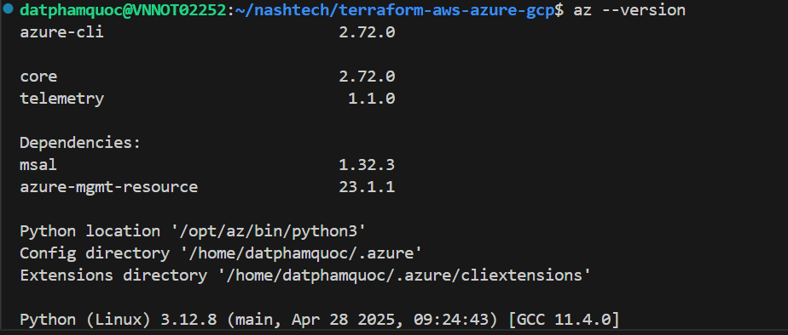

Install terraform

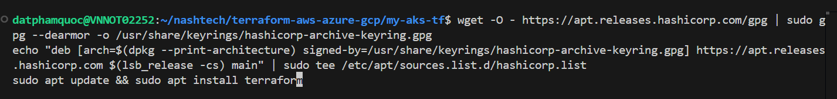

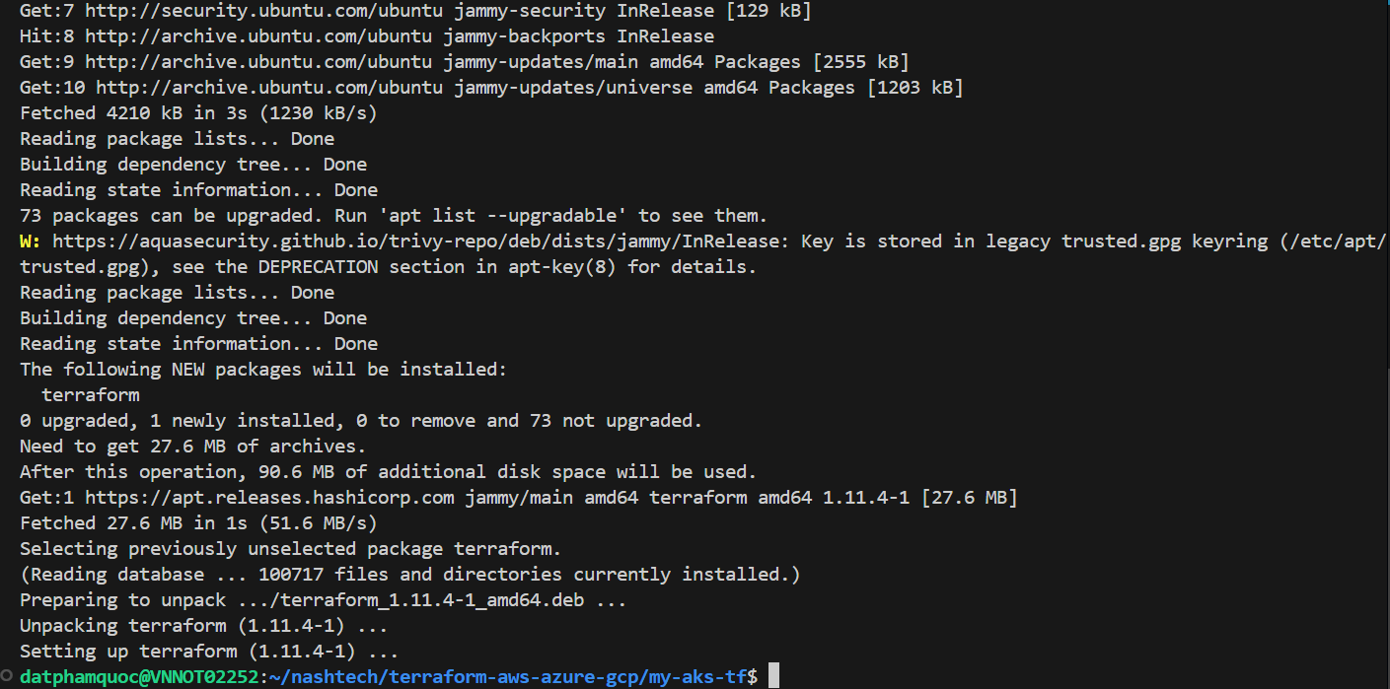

Verify terraform version  


Login to azure

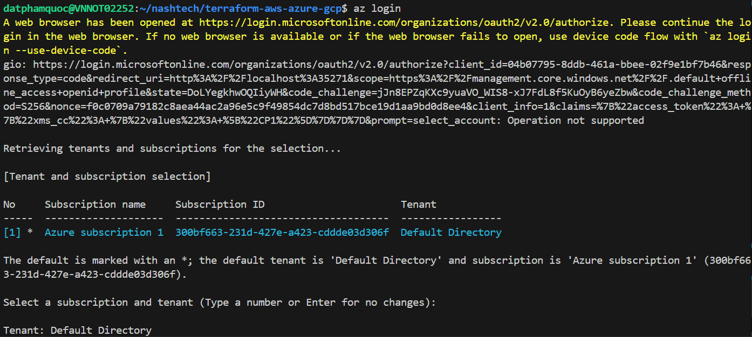

A subscription is created in Portal  
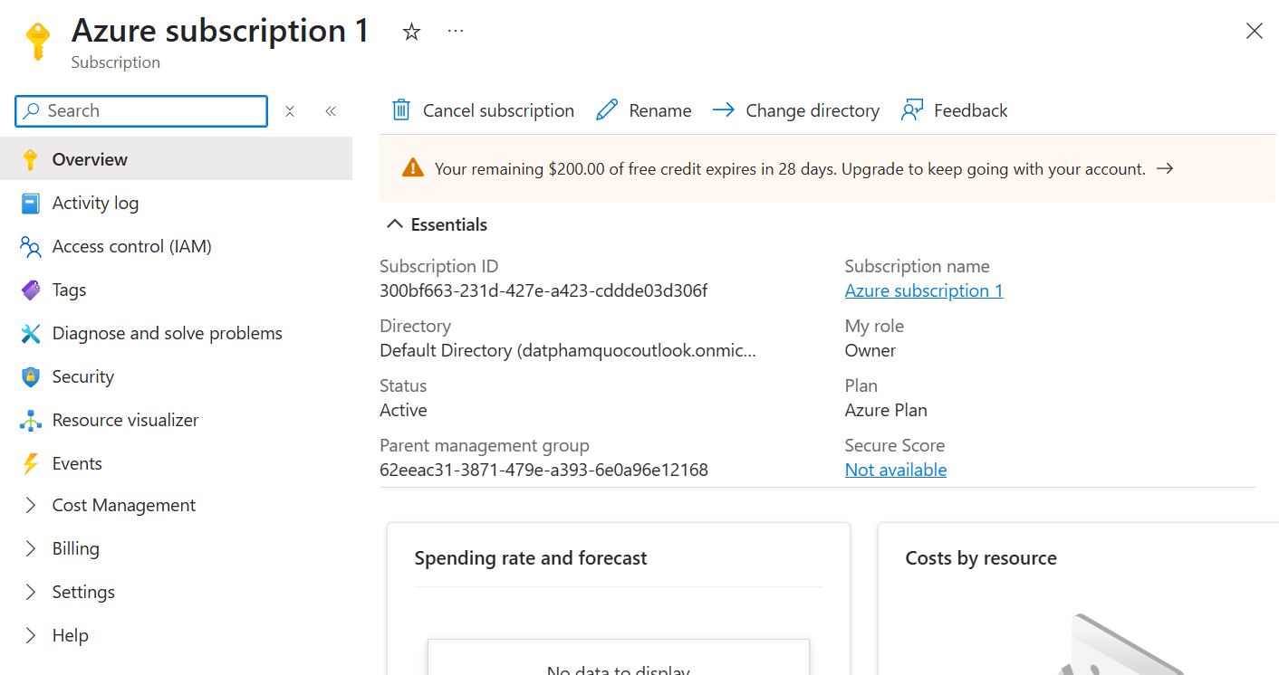

Create a Service Principal

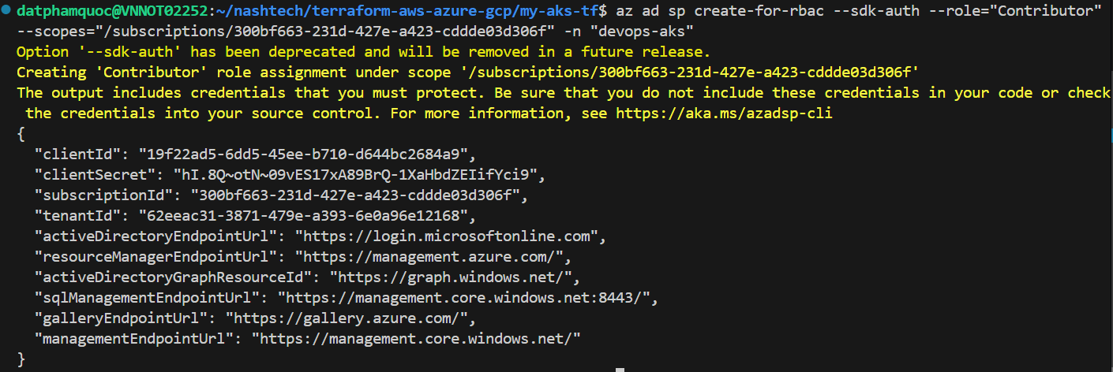

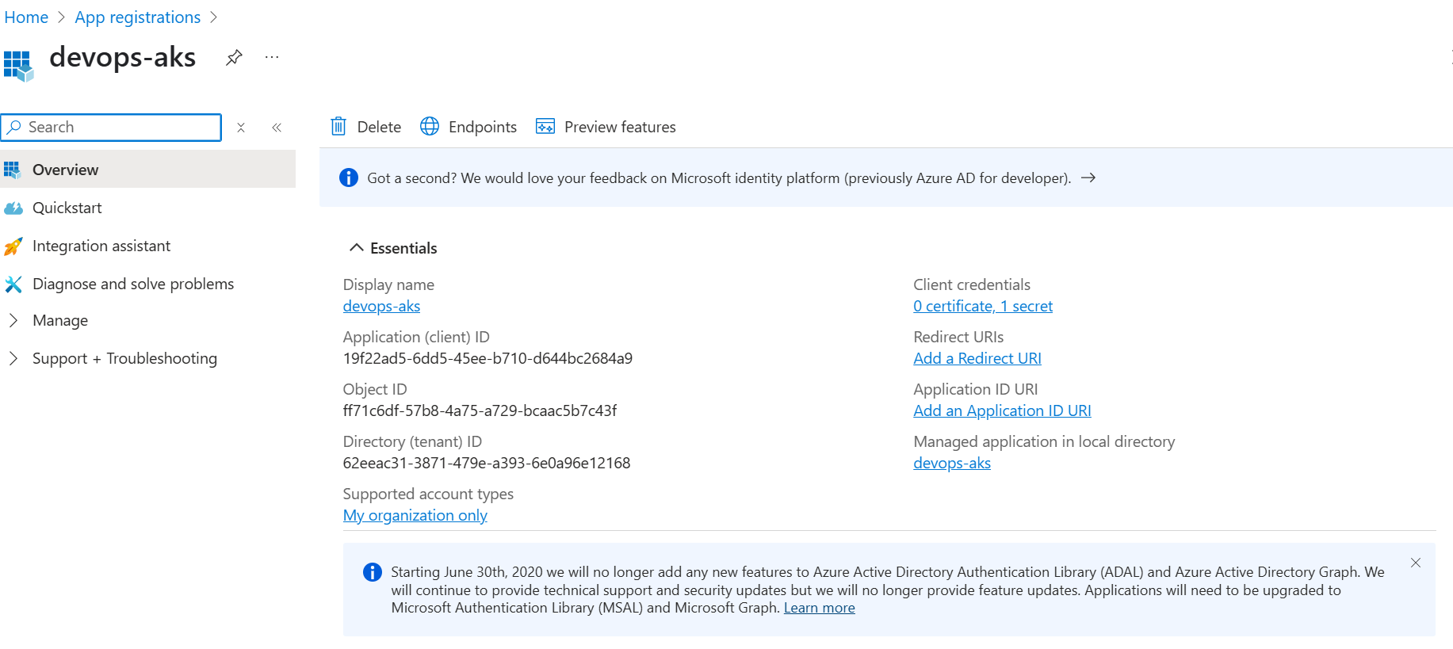

Export variables  
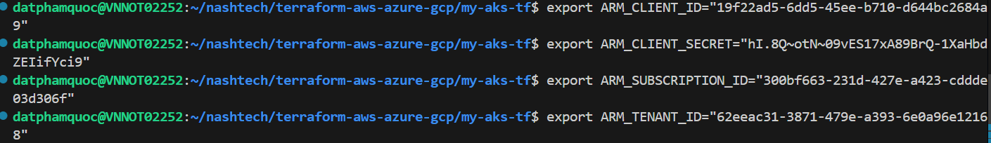

Verifying  
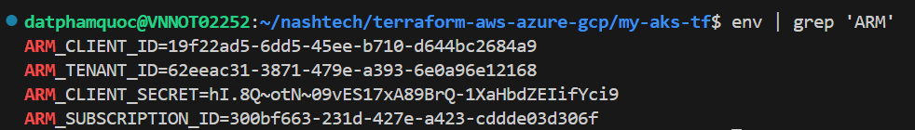

Install all modules required by terraform  
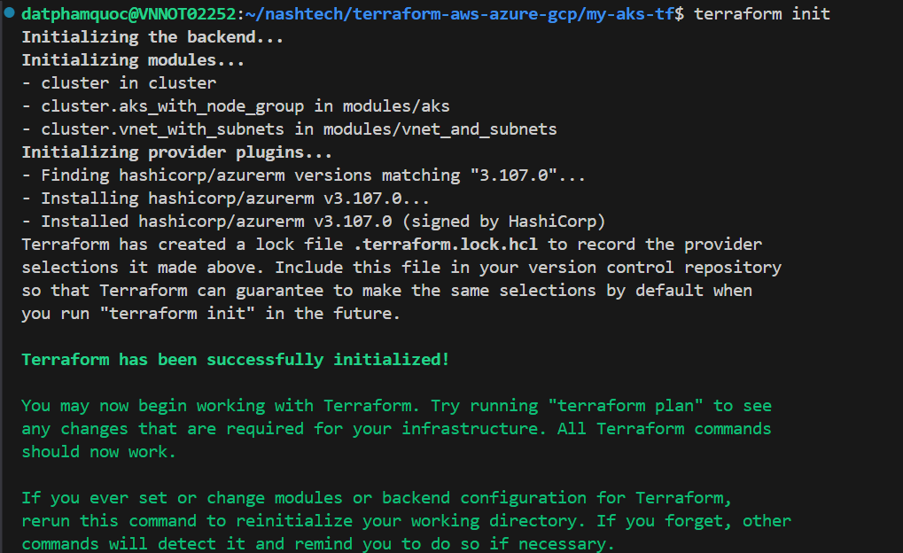

View terraform plan

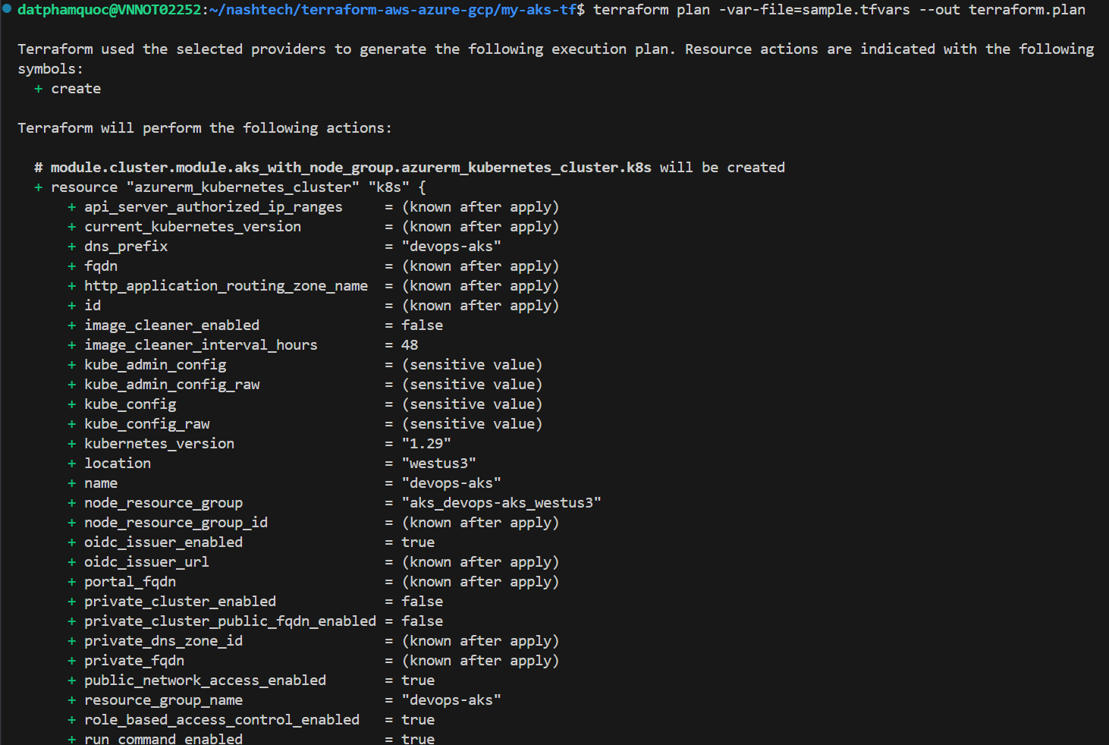

Install tf-summarize

wget <https://github.com/dineshba/tf-summarize/releases/latest/download/tf-summarize_linux_amd64.tar.gz>  
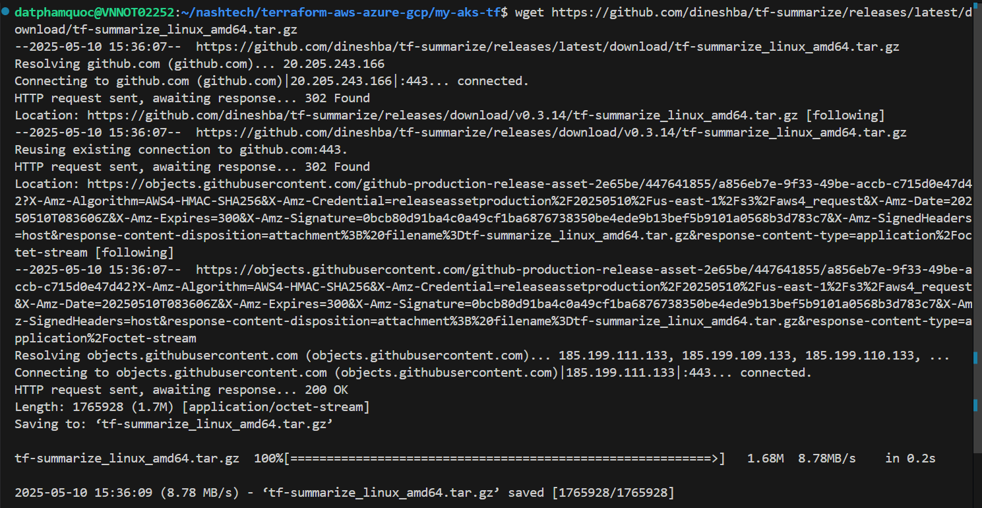

Unpack and install  


Verify tf-summarize  


View summary of terraform plan  
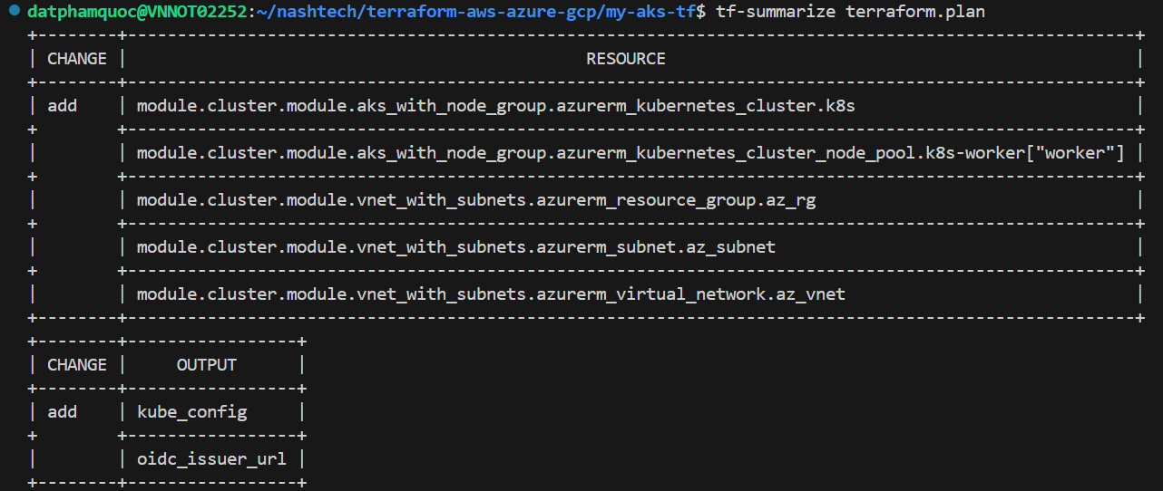

Apply terraform plan to AKS  
terraform apply -var-file="sample.tfvars"

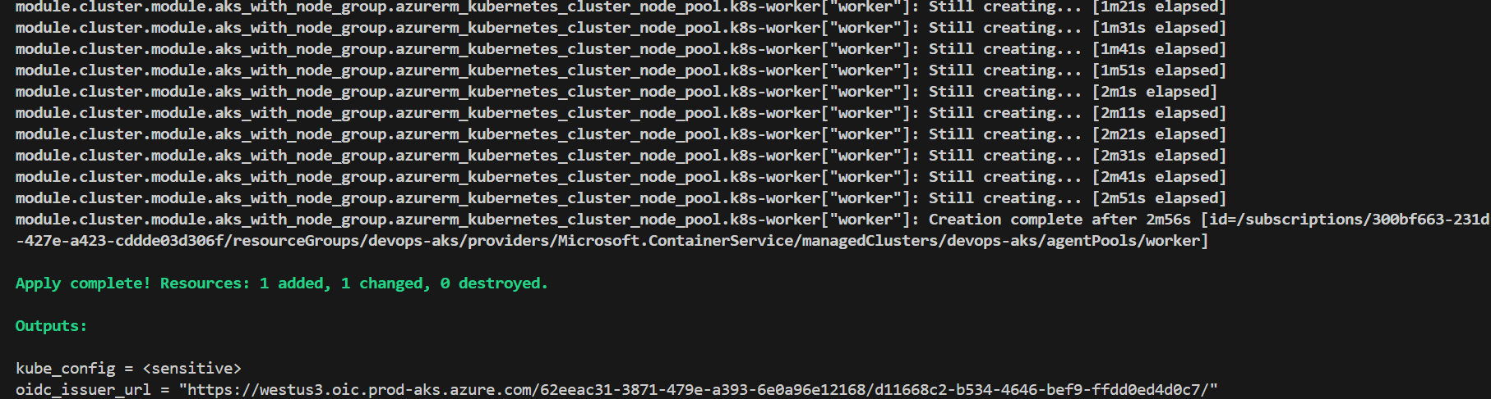

Verify in Azure portal

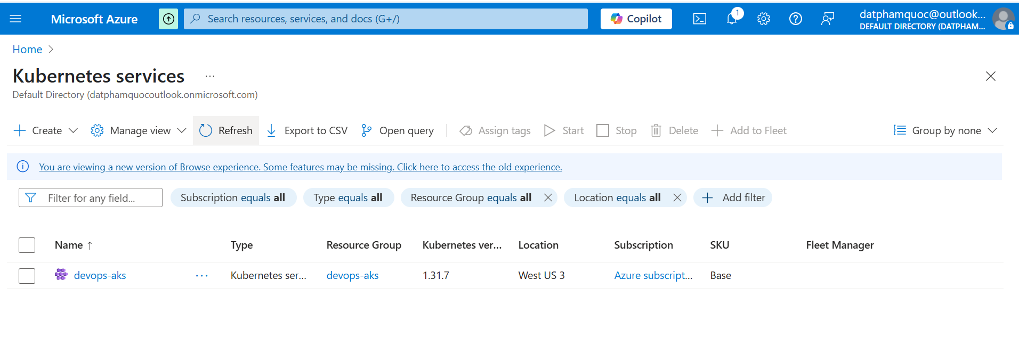

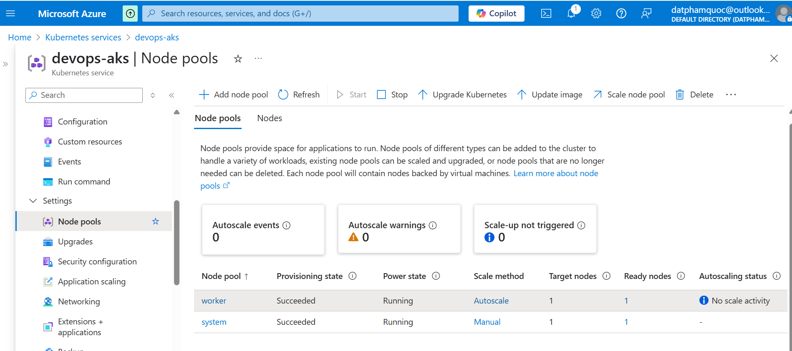

Connect to AKS cluster

az aks get-credentials --resource-group "devops-aks" --name "devops-aks" --subscription "300bf663-231d-427e-a423-cddde03d306f"



# You can check if you are pointing to the right kubernetes cluster by running following kubectl command

kubectl config current-context



List namespace

kubectl get namespace

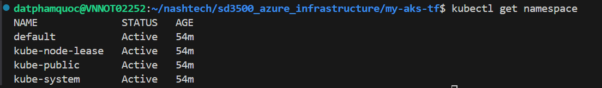

Cleanup

terraform destroy –var-file=sample.tfvars

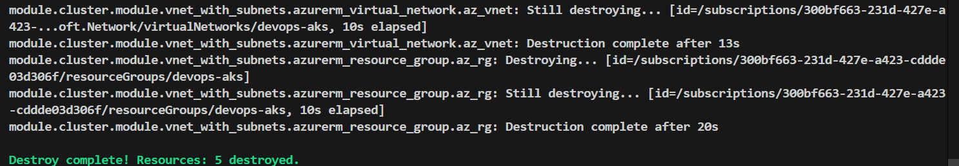

Verify in Azure portal

